**SOFTWARE DEVELOPMENT LABORATORY**

**EXPIMENT 5:**

**TRACK PROGRESS USING QUERIES**

**AIM:**

To track progress of work of each team member using queries using Monday.com. Queries provide a flexible way to track work. You can use several predefined queries, and you can create your own queries.

**PROCEDURE:**

In the Monday.com website sign up with email and password and create the project with the necessary details.

Open the release log by entering the project name and review the progress of the work in release log and in the sprint.

The activity log for the particular task can be viewed by clicking the task and then open.

Then click activity log in the right panel.

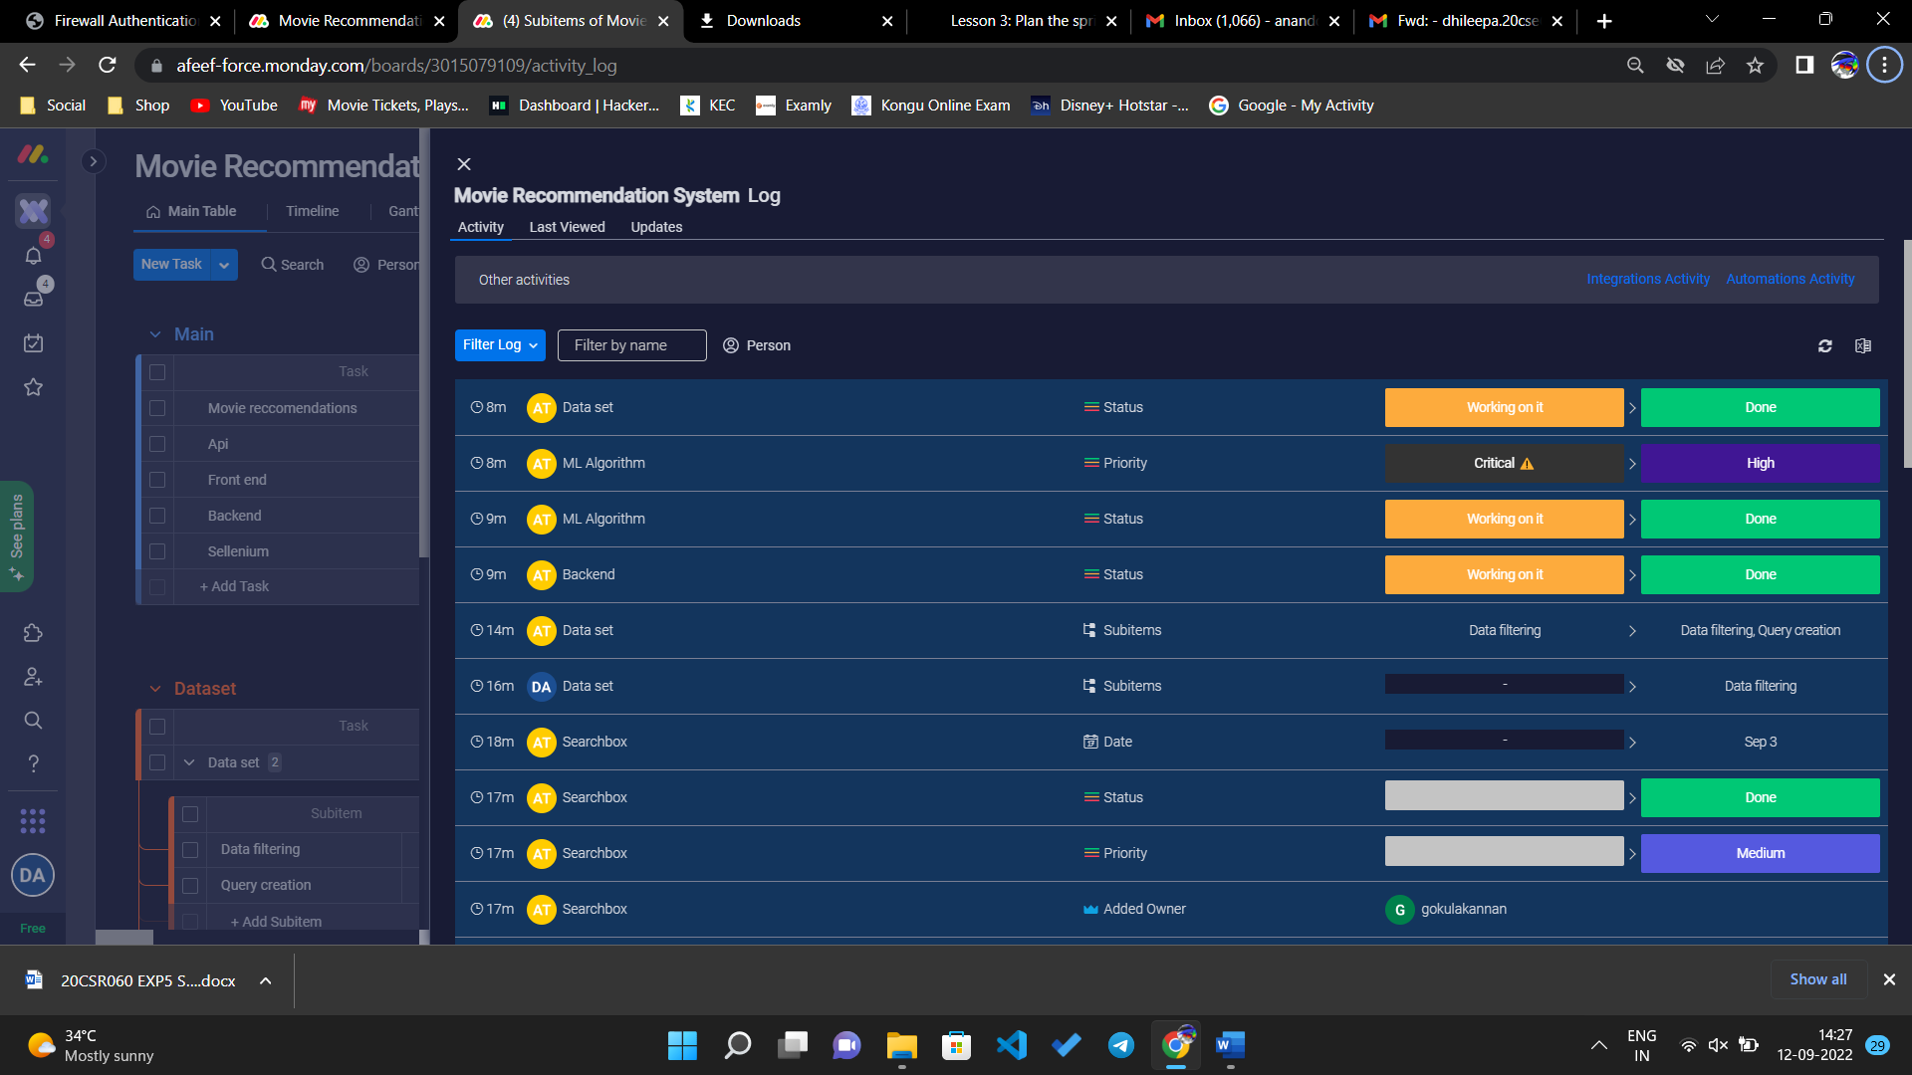

The progress can be updated or doubts can be clearing by queries by clicking chat icon in right side of task.

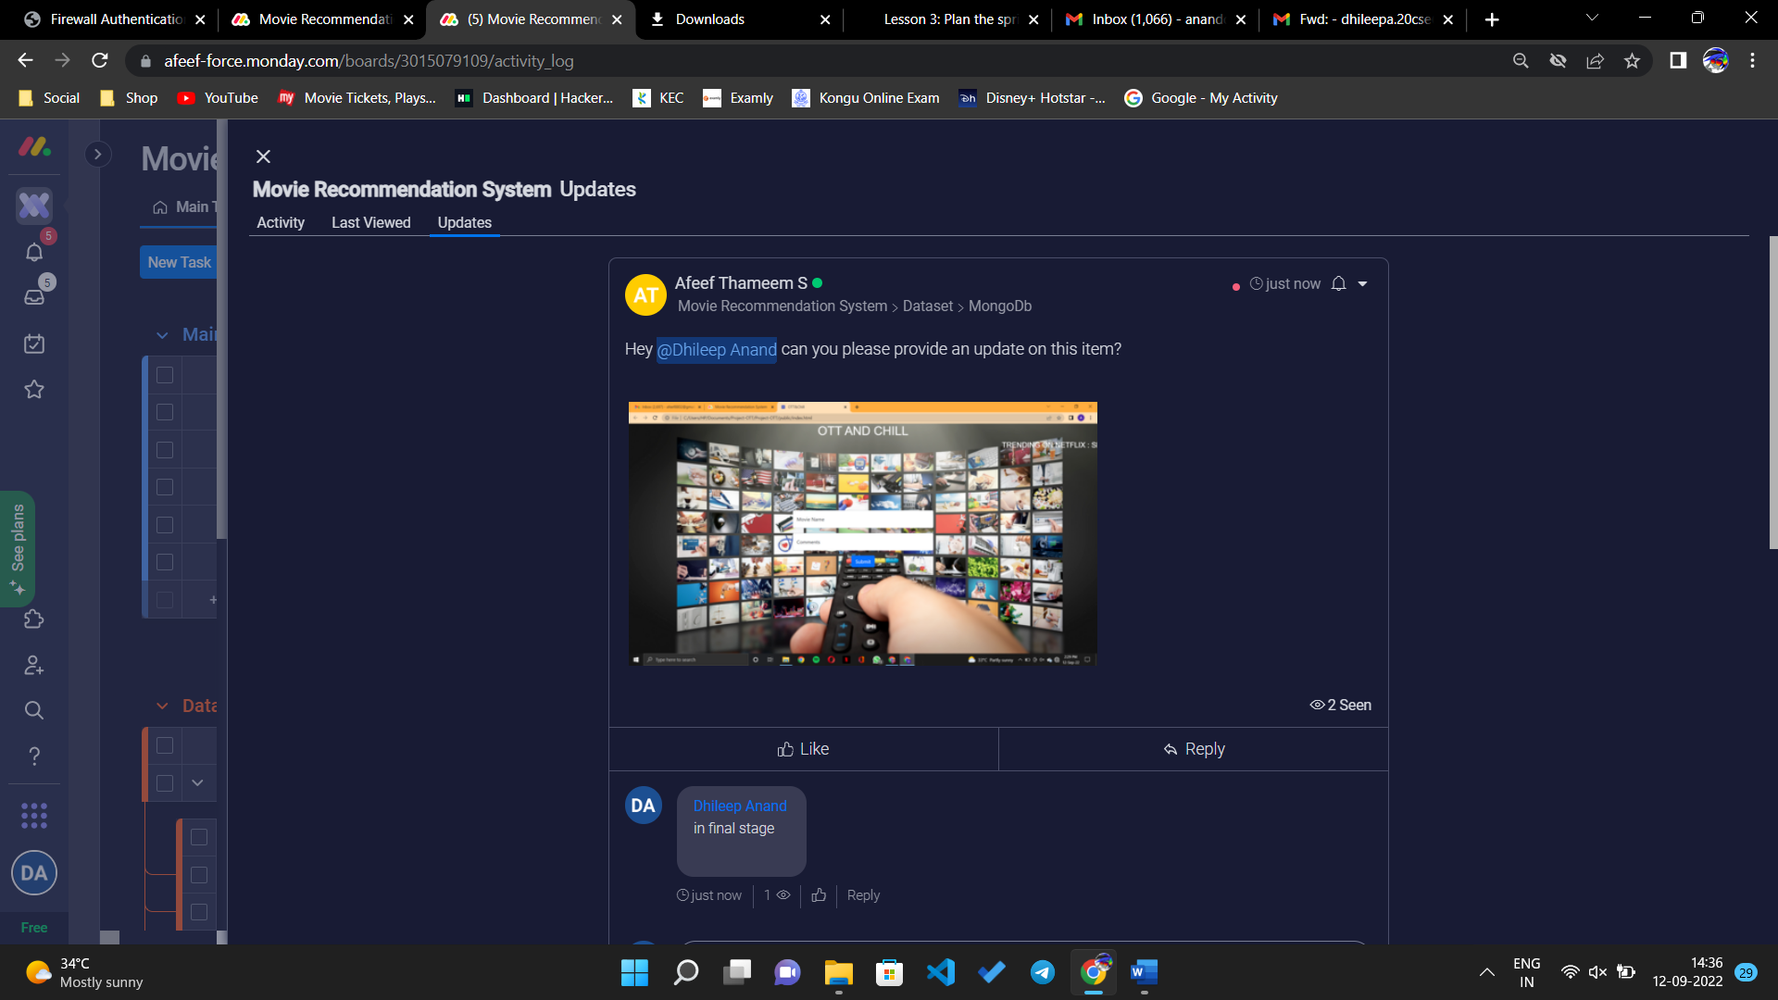

The conversation can be done by mentioning the team members also using symbol @.

The conversation can be start by clicking write an update and the queries can be updated.

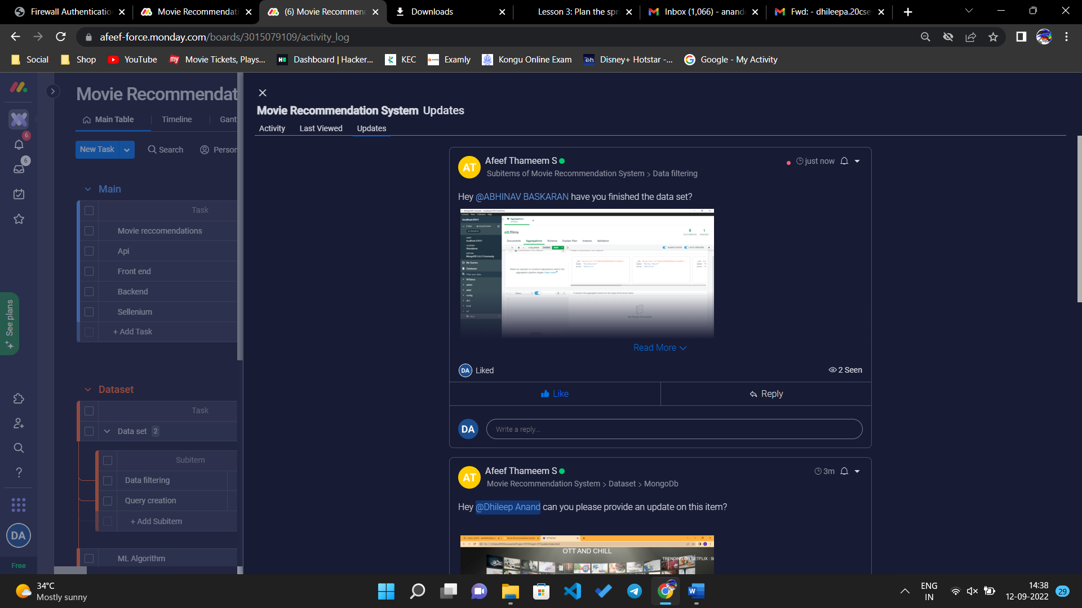

The files, emoji can also be updated. Then click update to send query to team members.

**CONCLUSION:**

Thus, the queries can be asked and the work progress can be updated with the team members.